DIS-ARC-Pipes-2016-

|  |  |
| --- | --- |
| ORDER DATEApr 06, 2016 | ORDER TOTAL  US $1,106.72  + US $33.00  shipping  **Order SQUIRREL EFFIGY PLATFORM PIPE,PLAINS INDIAN CATLINITE T-BOWL PIPE W/RELIEF CARVED COILED SNAKE,SIOUX INDIAN PIPE W/SPIRAL STEM,LARGE CHEROKEE GREAT PIPE PREFORM W/BEAR EFFIGY** [View order details - ORDER DATE Apr 06, 2016](http://payments.ebay.com/ws/eBayISAPI.dll?ViewPaymentStatus&transId=0&itemid=361523375137&_trksid=p2057872.m2749.l2673)[Contact seller](http://contact.ebay.com/ws/eBayISAPI.dll?ShowSellerFAQ&requested=gilbertcooper&iid=361523375137&redirect=0&_trksid=p2057872.m2749.l2652) - ORDER DATE Apr 06, 2016  [More actions - ORDER DATE Apr 06, 2016](http://www.ebay.com/myb/PurchaseHistory) |

4 items sold by [gilbertcooper](http://www.ebay.com/usr/gilbertcooper?_trksid=p2057872.m2749.l2754)

|  |  |  |
| --- | --- | --- |
| [SQUIRREL EFFIGY PLATFORM PIPE](http://www.ebay.com/itm/361523375137?_trksid=p2057872.m2749.l2649&ssPageName=STRK%3AMEBIDX%3AIT)  ( 361523375137 )  Delivered on Mon, Apr 11  Tracking number: [**Tracking number**9505515400066099001845](javascript:;)  [Add note](javascript:;) | ITEM PRICE:  US $103.50 | **Item SQUIRREL EFFIGY PLATFORM PIPE Orders 361523375137-0-0**[Leave feedback](http://feedback.ebay.com/ws/eBayISAPI.dll?LeaveFeedbackShow&useridto=gilbertcooper&transactID=0&item=361523375137&_trksid=p2057872.m2749.l2665)[Return this item](http://postorder.ebay.com/Return/ReturnViewSelectedItem?transactionId=0&itemId=361523375137&_trksid=p2057872.m2749.l3185)  [More actions](http://www.ebay.com/myb/PurchaseHistory) |

|  |  |  |
| --- | --- | --- |
| [PLAINS INDIAN CATLINITE T-BOWL PIPE W/RELIEF CARVED COILED SNAKE](http://www.ebay.com/itm/361523378013?_trksid=p2057872.m2749.l2649&ssPageName=STRK%3AMEBIDX%3AIT)  ( 361523378013 )  Delivered on Mon, Apr 11  Tracking number: [**Tracking number**9505515400066099001845](javascript:;)  [Add note](javascript:;) | ITEM PRICE:  US $124.72 | **Item PLAINS INDIAN CATLINITE T-BOWL PIPE W/RELIEF CARVED COILED SNAKE Orders 361523378013-0-0** almost 3" long T-Bowl Pipe that is 3" tall by 1" wide. This pipe is unique because it has a rattlesnake carved around the bowl. Most likely this pipe was made around the 1910-1920's and sold to tourists. It has definitely been used. The bowl is 1/2" by 1-1/2" deep. The stem hole is 7/16" in diameter. This pipe has been well used. Around the top of the bowl it has been beat on quite a bit to knock the tobacco out of it. |

|  |  |  |
| --- | --- | --- |
| [SIOUX INDIAN PIPE W/SPIRAL STEM](http://www.ebay.com/itm/361523381141?_trksid=p2057872.m2749.l2649&ssPageName=STRK%3AMEBIDX%3AIT)  ( 361523381141 )  Delivered on Mon, Apr 11  Tracking number: [**Tracking number**9505515400066099001845](javascript:;)  [Add note](javascript:;) | ITEM PRICE:  US $720.00 | **Item SIOUX INDIAN PIPE W/SPIRAL STEM Orders 361523381141-0-0**  Up for auction is a matching pipe and stem. It measures 20" long overall. The stem is 16-1/2" long. It appears to be maple. The pipe is a Calumet Style. It has a drill hole for suspension in one spot. There are a couple old labels on the pipe. They read, Kicking Bear, Sioux, 1889. That is just what the labels read. The pipe is 4" long by 2-1/2" tall and well used and is 1-1/8" in thickness. |

|  |  |
| --- | --- |
| [LARGE CHEROKEE GREAT PIPE PREFORM W/BEAR EFFIGY](http://www.ebay.com/itm/361523381785?_trksid=p2057872.m2749.l2649&ssPageName=STRK%3AMEBIDX%3AIT)  ( 361523381785 )  Delivered on Mon, Apr 11  Tracking number: [**Tracking number**9505515400066099001821](javascript:;)  [Add note](javascript:;) | ITEM PRICE:  US $15 |

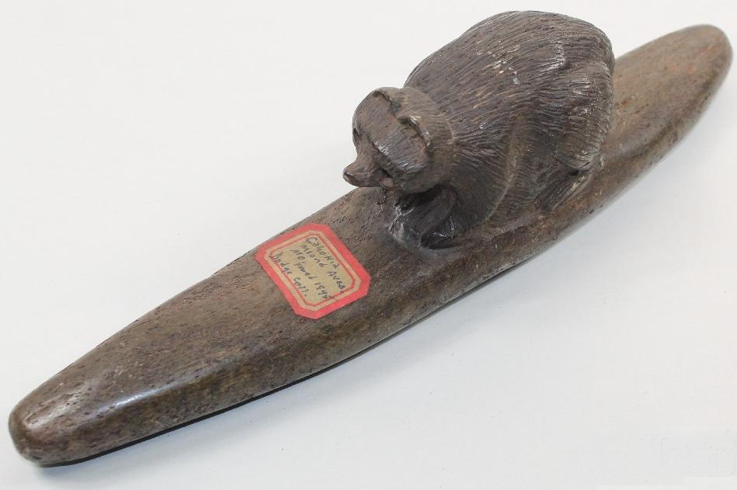

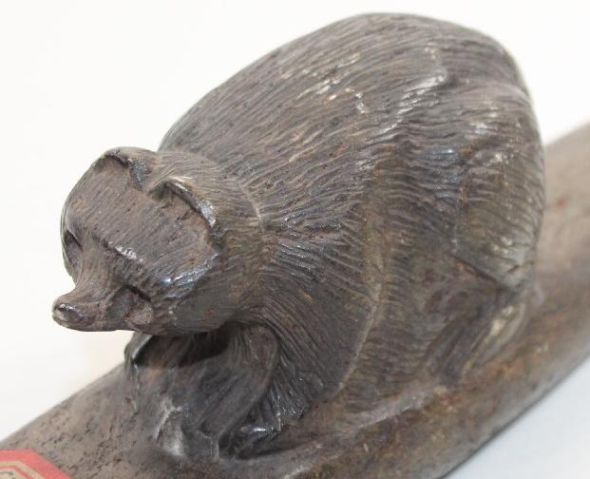L

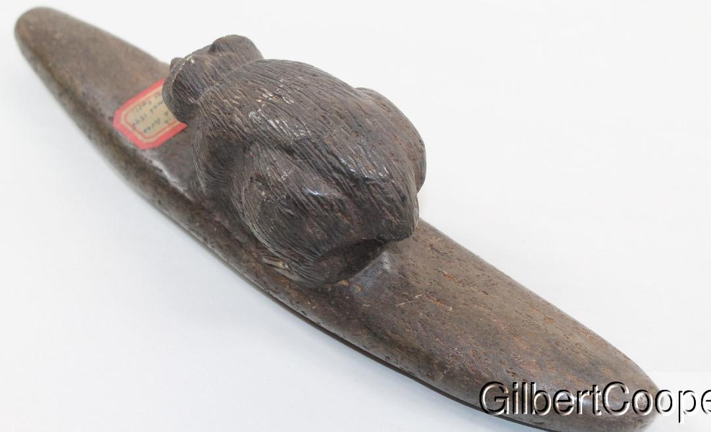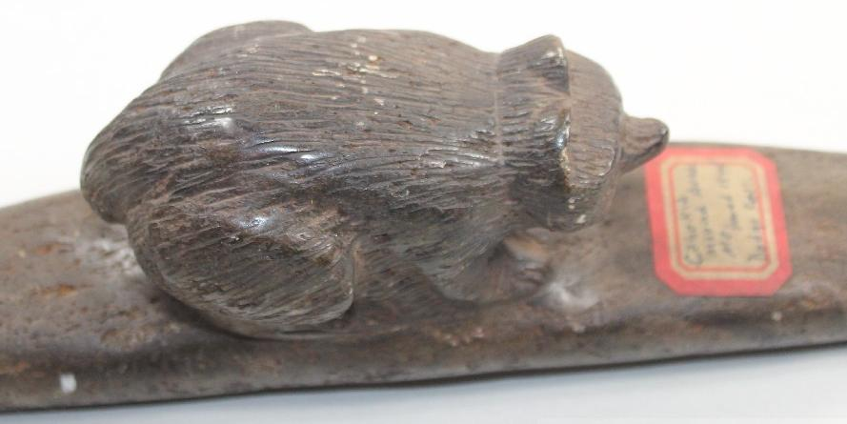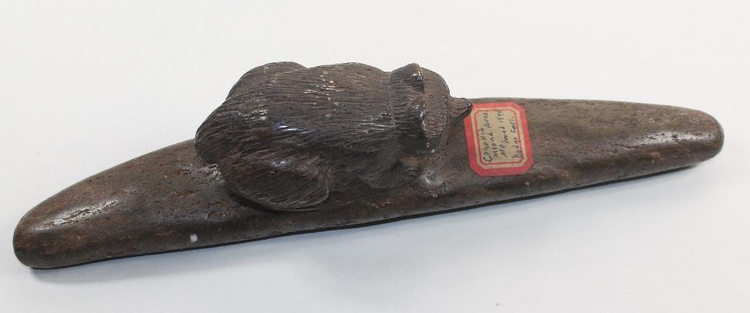

Large Cherokee Great Pipe Preform that has a Bear Effigy on it. It should date in the early 1900's. It was never drilled. There is an old sticker that reads Cahokia Area, 1845, Dodge Collection. My own personal opinion is that this piece is hands down a Cherokee piece and will date in the 1900's and has never seen the Cahokia Area. This piece measures is 12-1/2" long by 3-1/4" tall by 2-1/2" wide. It is made out of Carolina Steatite.

Matching pipe and stem. It measures 20" long overall. The stem is 16-1/2" long. It appears to be maple. The pipe is a Calumet Style. It has a drill hole for suspension in one spot. There are a couple old labels on the pipe. They read, Kicking Bear, Sioux, 1889. That is just what the labels read. The pipe is 4" long by 2-1/2" tall and well used and is 1-1/8" in thickness.

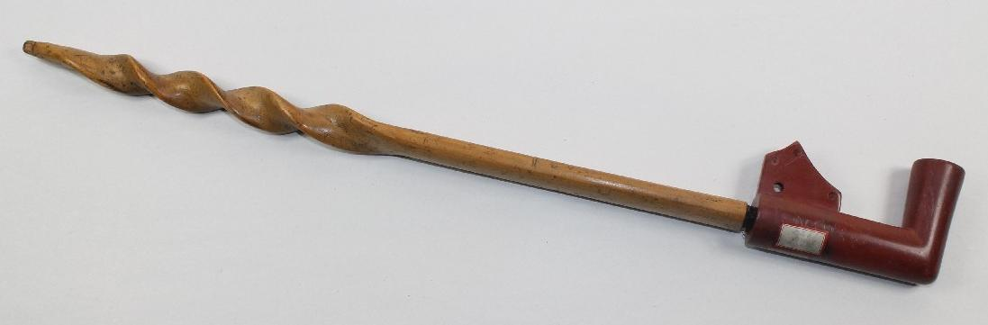

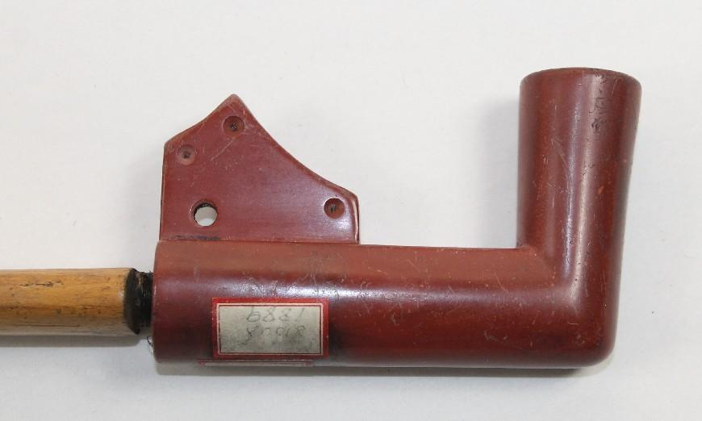

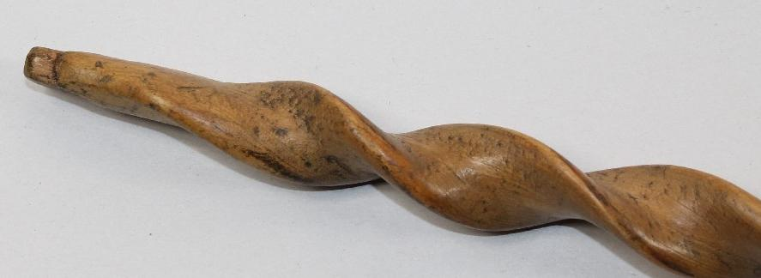 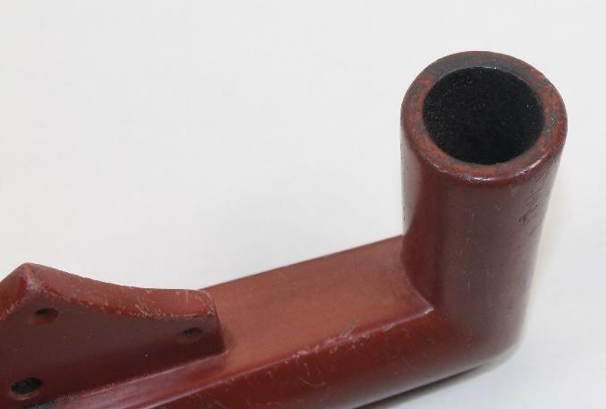

almost 3" long T-Bowl Pipe that is 3" tall by 1" wide. This pipe is unique because it has a rattlesnake carved around the bowl. Most likely this pipe was made around the 1910-1920's and sold to tourists. It has definitely been used. The bowl is 1/2" by 1-1/2" deep. The stem hole is 7/16" in diameter. This pipe has been well used. Around the top of the bowl it has been beat on quite a bit to knock the tobacco out of it.

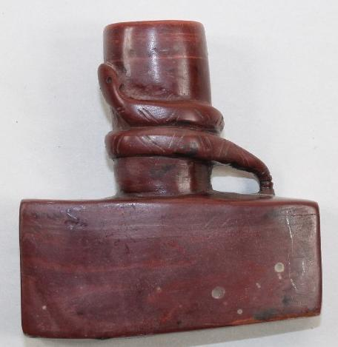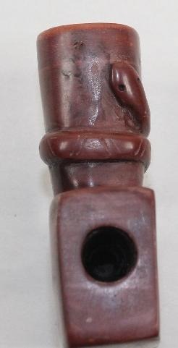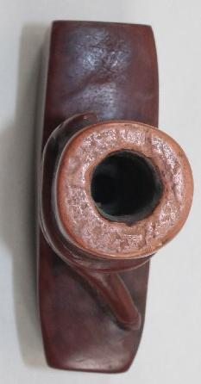

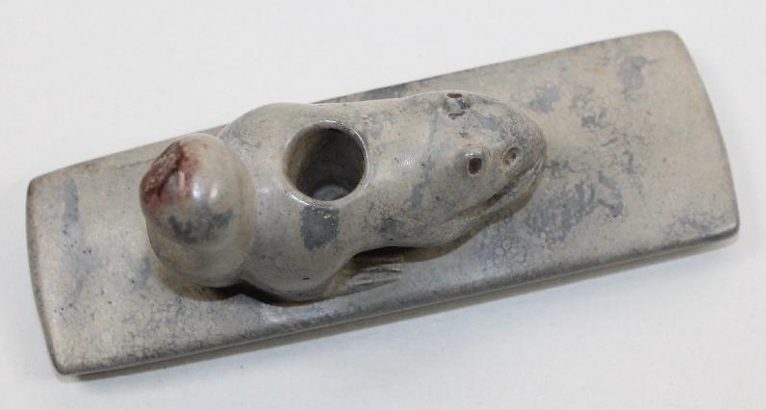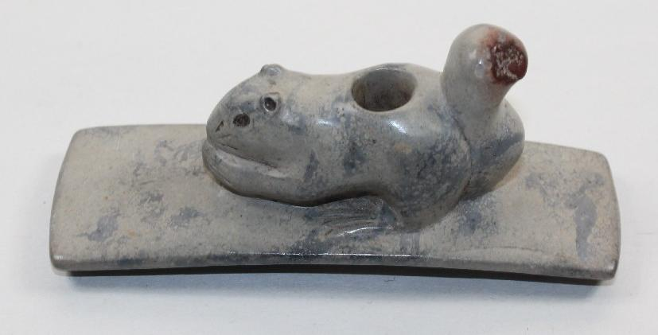

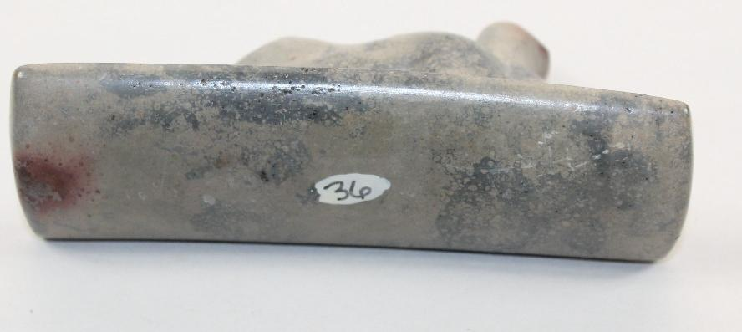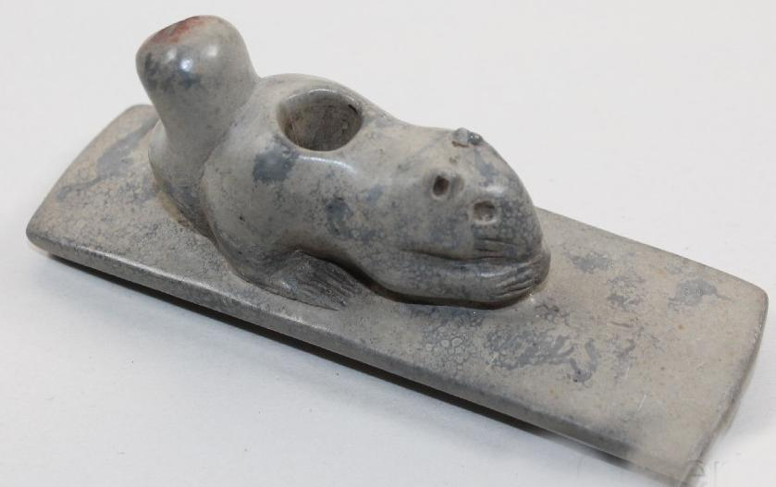

Ohio Hopewell squirrel Effigy Platform Pipe. It is 4" long by 1-1/2" tall by 1-3/8" wide. It is highly detailed. This piece was in the Bob Olson Collection for about 25 years. Bob got this piece from Gary Litherland. The material is exactly what it should be, Ohio pipestone.